**EXERCISE 3 – SIMPLE ANDROID APPLICATION FOR NATIVE CALCULATOR**

**Aim:**

To develop a Simple Android Application for Native Calculator. **Creating a New project:**

* • Open Android Studio and then click on **File -> New -> New project.**
* • Then

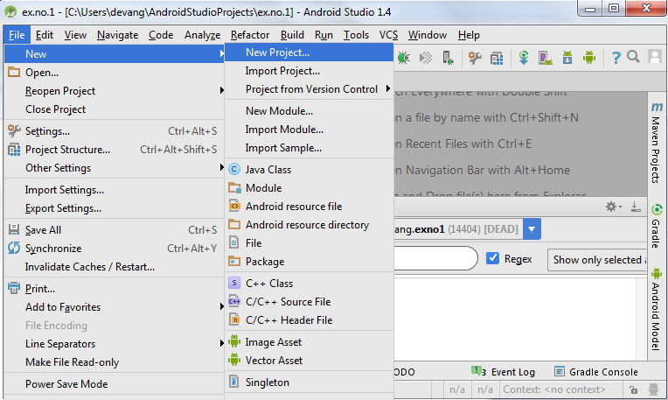

* Then type the Application name as “**ex.no.1″** and click **Next.**

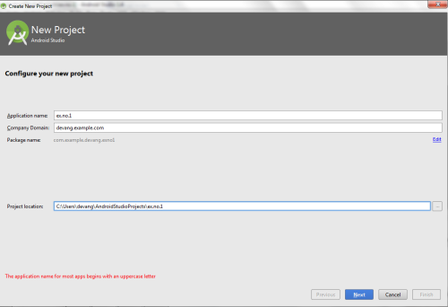

* Then select the **Minimum SDK** as shown below and click **Next**.

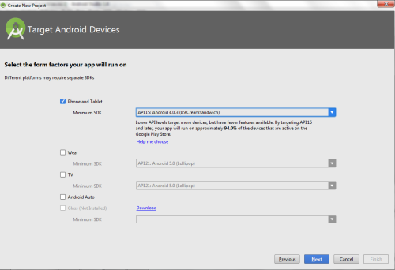

* Then select the **Empty Activity** and click **Next.**

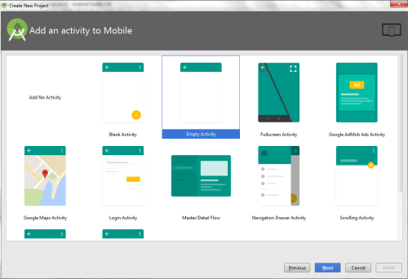

*  Finally click F**inish**.

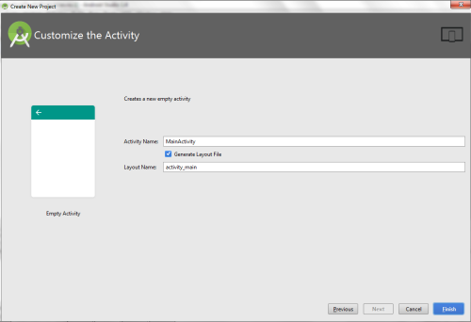

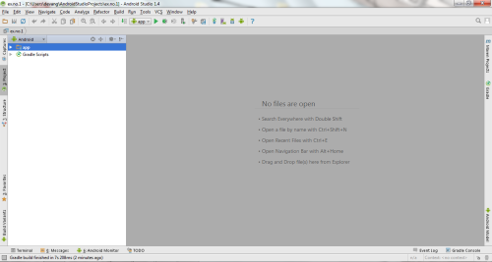

**Designing layout for the Android Application:**

* • Click on **app -> res -> layout -> activity_main.xml.**

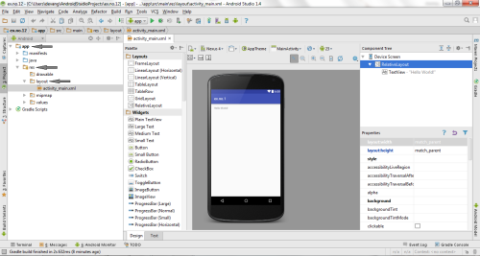

* Now click on **Text** as shown below.

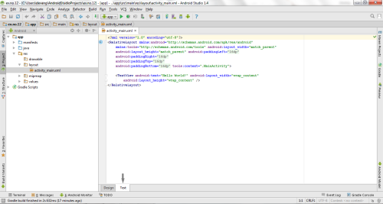

* Then delete the code which is there and type the code as given below.

**Code for Activity_main.xml:**

<?xml version="1.0" encoding="utf-8"?>

<LinearLayout

xmlns:android="http://schemas.android.com/apk/res/android"

android:orientation="vertical"

android:layout_width="match_parent"

android:layout_height="match_parent"

android:layout_margin="20dp">

<LinearLayout

android:id="@+id/linearLayout1"

android:layout_width="match_parent"

android:layout_height="wrap_content"

android:layout_margin="20dp">

<EditText

android:id="@+id/editText1"

android:layout_width="match_parent"

android:layout_height="wrap_content"

android:layout_weight="1"

android:inputType="numberDecimal"

android:textSize="20sp" />

<EditText

android:id="@+id/editText2"

android:layout_width="match_parent"

android:layout_height="wrap_content"

android:layout_weight="1"

android:inputType="numberDecimal"

android:textSize="20sp" />

</LinearLayout>

<LinearLayout

android:id="@+id/linearLayout2"

android:layout_width="match_parent"

android:layout_height="wrap_content"android:layout_margin="20dp">

<Button

android:id="@+id/Add"

android:layout_width="match_parent"

android:layout_height="wrap_content"

android:layout_weight="1"

android:text="+"

android:textSize="30sp"/>

<Button

android:id="@+id/Sub"

android:layout_width="match_parent"

android:layout_height="wrap_content"

android:layout_weight="1"

android:text="-"

android:textSize="30sp"/>

<Button

android:id="@+id/Mul"

android:layout_width="match_parent"

android:layout_height="wrap_content"

android:layout_weight="1"

android:text="*"

android:textSize="30sp"/>

<Button

android:id="@+id/Div"

android:layout_width="match_parent"

android:layout_height="wrap_content"

android:layout_weight="1"

android:text="/"

android:textSize="30sp"/>

</LinearLayout>

<TextView

android:id="@+id/textView"

android:layout_width="match_parent"

android:layout_height="wrap_content"

android:layout_marginTop="50dp"

android:text="Answer is"

android:textSize="30sp"

android:gravity="center"/>

</LinearLayout>

* • Now click on Design and your application will look as given below.

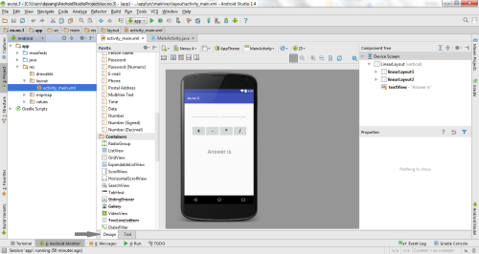

* So now the designing part is completed.

**Java Coding for the Android Application:**

* • Click on **app -> java -> com.example.exno3 -> MainActivity.**

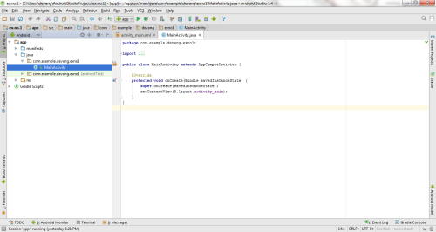

* Then delete the code which is there and type the code as given below.

Code for MainActivity.java:

package com.example.devang.exno3;

import android.os.Bundle;

import android.support.v7.app.AppCompatActivity;

import android.text.TextUtils;

import android.view.View;

import android.view.View.OnClickListener;

import android.widget.Button;

import android.widget.EditText;

import android.widget.TextView;

public class MainActivity extends AppCompatActivity implements OnClickListener

{

//Defining the Views

EditText Num1;

EditText Num2;

Button Add;

Button Sub;

Button Mul;

Button Div;

TextView Result;

@Override

public void onCreate(Bundle savedInstanceState)

{

super.onCreate(savedInstanceState);

setContentView(R.layout.activity_main);

//Referring the Views

Num1 = (EditText) findViewById(R.id.editText1);

Num2 = (EditText) findViewById(R.id.editText2);

Add = (Button) findViewById(R.id.Add);

Sub = (Button) findViewById(R.id.Sub);

Mul = (Button) findViewById(R.id.Mul);

Div = (Button) findViewById(R.id.Div);

Result = (TextView) findViewById(R.id.textView);

// set a listener

Add.setOnClickListener(this);

Sub.setOnClickListener(this);

Mul.setOnClickListener(this);

Div.setOnClickListener(this);

}

@Override

public void onClick (View v)

{

float num1 = 0;

float num2 = 0;

float result = 0;

String oper = "";

// check if the fields are empty

if (TextUtils.isEmpty(Num1.getText().toString()) || TextUtils.isEmpty(Num2.getText().toString()))

return;

// read EditText and fill variables with numbers

num1 = Float.parseFloat(Num1.getText().toString());

num2 = Float.parseFloat(Num2.getText().toString());

// defines the button that has been clicked and performs the corresponding operation

// write operation into oper, we will use it later for output

switch (v.getId())

{

case R.id.Add:

oper = "+";

result = num1 + num2;

break;

case R.id.Sub:

oper = "-";

result = num1 - num2;

break;

case R.id.Mul:

oper = "*";

result = num1 * num2;

break;

case R.id.Div:

oper = "/";

result = num1 / num2;

break;

default:

break;

}

// form the output line

Result.setText(num1 + " " + oper + " " + num2 + " = " + result);

}

}

* • So now the Coding part is also completed.
* • Now run the application to see the output.

**Output:**

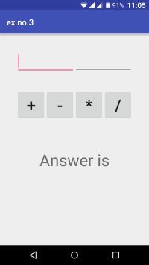 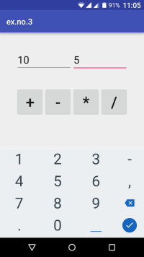 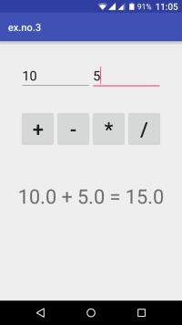

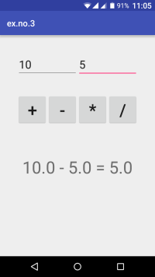 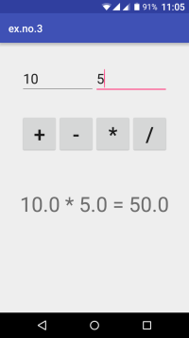 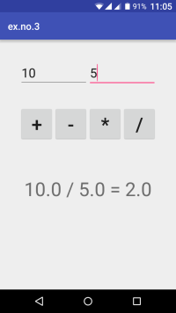

**Result:**

Thus a Simple Android Application for Native Calculator is developed and executed successfully.

**EXERCISE 3.1:**

Execute the above exercise of Native Calculator in Android studio and show the exact GUI output? [2]

**EXERCISE 3.2:**

Develop an android application for Scientific Calculator. Mathematical functionality should be present e.g. Sin, Tan, Cos, Sqrt, log etc.